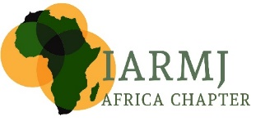

AGENDA

- Attendance Register

- Welcome. President of the Africa Chapter. Justice Dunstan Mlambo - Unopposed Motion of President - Tributes in honour of the Late Justice Ochieng (Nairobi) and former Treasurer Tjerk Damstra (South Africa)

- Apologies.

- Chapter Update
2024-2025
President
  - Sharm el Sheikh Regional Conference
  - Reconstituted Sub Regional Chapters – East Africa and Horn of Africa – Justice Cheborion; Southern Africa – Judge Zione Ntaba; North Africa – Judge Zouheir Ben Tanfous; West and Central Africa - ??
  - Country Convenors
  - Working Parties Participation – Working Parties participation –
  - Africa Chapter Professional Development programme (Vanja)
- Upcoming Conferences*
  - As 2026 marks the Founding Meeting hosted in South Africa 2006 - Proposal that the 20th Anniversary of the Africa Chapter be hosted in S Africa. Possibly late November next year, in Cape Town or Ethekwini (Durban)
  - Formation of LoC – Convenor – Mr Ahmed Arbee
  - Funding – Members to assist in looking for funding to assist

- Membership and Financials*
Treasurer. Ahmed Arbee

The Africa Chapter Banking account is still registered in the initial name ie IARLJ. Resolution required to: amend name in line with the Global Association to IARMJ
Nominate additional signatories to the account preferably from South Africa due to the Africa Chapter account being held at Absa Bank, Pretoria, South Africa

- General and Closure

